J1699-3 User Notes

for OBD, EOBD And IOBD Compliance Testing
Table of Contents

1. Background 3
2. J1699-3 Application Overview 3
2.1. Preparing to run the J1699-3 application 4
2.1.1. Test Set-up 4
2.1.2. Other things to consider before beginning 4
2.2. Identifying testing issues 5
2.3. Proceeding on after a FAILURE is detected 5
3. User Provided Information 7
3.1. J2534-1 Interface Selection 7
3.2. Test Selection 7
3.3. Vehicle Information 7
3.4. Compliance Test Type 7
3.5. Optional User Information 8
4. Static Test Overview 9
4.1. Static Test Sample Run 9
4.1.1. Starting the Static Test 9
4.1.2. Test 9.19 – The Permanent Code Drive Cycle 11
4.1.3. The End of the Static Tests 12
5. Dynamic Test Overview 14
5.1. Dynamic Test Sample Run 15
5.1.1. Starting the Dynamic Test 15
5.1.2. Test 10.11 – The CARB Drive Cycle 17
5.1.3. Test 11.2 – The Manufacturer Specific Drive Cycle 18
6. Sample Log File 21

Background
SAE J1699-3 is a set of test cases that defines an industry wide OBD compliance test for vehicles. All manufacturers that sell vehicles in North America use these tests to demonstrate compliance with the Generic Scan Tool, Modes $01-$0A. These Modes (detailed in SAE J1979 / ISO 15031-5) were legislated so that aftermarket repair facilities could access OBD controller information with one common or Generic Scan Tool. SAE J1699-3 also has provisions for testing compliance with EOBD.

The J1699-3 application is a piece of software that automates the test cases defined in the SAE J1699-3 document. The J1699-3 application runs on a generic, Windows ™ based, PC that has a SAE J2534-1 Pass-Thru Interface installed on it to access the vehicle networks.

J1699-3 Application Overview
The J1699-3 application can be found at http://sourceforge.net/projects/j1699-3. It is based on the SAE J1699-3 document, which specifies the compliance test cases for vehicles that communicate using the diagnostic test modes specified in SAE J1979 / ISO 15031-5. Bugs and new feature request are tracked in SourceForge and are summarized in the file “J1699-3 Work Status.xls”, which is included with the J1699-3 application release.

The tests are broken into two major phases: Static Tests (sections 5-9 in the J1699-3 document) and Dynamic Tests (sections 10-11 in the J1699-3 document). Each phase will create its own log file (the format is described in the file “LogFileFormat.doc”, which is included with the J1699-3 application release) to record the vehicle network traffic and test results. When the J1699-3 application starts up, you will be prompted to select either the Static Tests or the Dynamic Tests.

The Static Tests will require faults to be induced on the vehicle as well as the vehicle to be driven through a CARB Drive Cycle. These tests must be completed without interruption (that is, you cannot exit and later re-enter the test where it was stopped, it must start again from the beginning). Once these tests are started, they must be run to completion; including the CARB Drive Cycle, which is at the end of the Static Tests and is used to verify Permanent DTCs.

The Dynamic Test consists of two sections: the CARB Drive Cycle (section 10 in the J1699-3 document) and the Manufacturer Specific Drive Cycle (section 11 in the J1699-3 document). The CARB Drive Cycle tests are run first, without interruption, and must be completed before you can proceed on to the Manufacturer Specific Drive Cycle. Because the Manufacturer Specific Drive Cycle may take more than one trip to complete, you may enter and exit it as many times as needed. Your progress can be monitored using the Manufacturer Specific Drive Cycle Monitor Screen (Test 11.2). The J1699-3 application will not allow you to complete Test 11.2 until the appropriate I/M Readiness Flags are set to READY and the appropriate In-Use Performance Tracking counters have changed.

Preparing to run the J1699-3 application

Test Set-up
Before starting the J1699-3 application, you should:
- Locate and boot-up the PC that will be used to run the J1699-3 software. Be sure it has the latest version of J1699-3 software on it.
- Locate the J2534-1 Interface that will be used. Be sure that the corresponding J2534-1 Interface software has been installed on the PC you will be using.
- Connect the J2534-1 Interface to the vehicle to be tested.
- Connect the J2534-1 Interface to the PC.

Other things to consider before beginning
The following is a quick list of points that will make running the J1699-3 application easier:

- A slow PC or a slow J2534-1 Interface may cause false failures. The user should try to avoid having other applications running on the PC in the background.

- Contact your J2534-1 Interface supplier for their latest firmware release. The J1699-3 application depends upon the correct operation of the J2534-1 Interface. Incorrect or faulty operation of the J2534-1 Interface may cause false failures.

- J1699-3 may not work correctly if you set multiple DTC’s.

- When testing a vehicle make sure that ALL OBD controllers have been updated. All too often, a calibrator will ask you to test a new ECM software release and not update the TCM, leading to a failure of the J1699-3 test.

- When prompted to enter the Model Year, be sure to enter it as a 4-digit, numeric, value. You must enter the correct Model Year (e.g., 2007) with no other text, as this value is used for some of the J1699-3 evaluation criteria.

- Be aware that the J1699-3 application will create two log files: one for the Static Tests (Test 5-9) and one for the Dynamic Tests (Tests 10-11). Each log file will have a different name. The Static Test log file will be named based on the Model Year, Make, and Model entered at the start of the J1699-3 application. The Dynamic Test log file will be name will be based on the VIN and will be automatically generated by what is stored in Mode 9 VID 02 (or user entered file name if a valid VIN is not present on the vehicle). In either case, the J1699-3 application will not over-write an existing file – it will append an “-xx”; where the xx will start at 1 and continue to increment each time an existing file name is re-used. Remember, if you are re-entering Test 11 and are prompted for a file name, make sure to use the same name as you did when the Dynamic tests were originally started. This is important so that the J1699-3 application can determine if Test 10 was completed and so the subsequent results can be appended to the original log file.

- When setting a ‘Type B’ DTC (that is, a DTC that does not set both a Pending and Confirmed DTC in the same drive cycle) make sure you know the FAIL and PASS criteria for that DTC. I typically will disconnect a MAP or MAF sensor because it runs extremely fast; it runs at idle and does not require a vehicle speed input. This is not true for all vehicles! Know your vehicle!

- Under certain error conditions a temporary log file may be the only log file created. The name follows the format j16xx.tmp; where xx is a hex number assigned by the operating system. This temporary file follows the same format as a normal J1699-3 log file and may provide valuable information about the failure.

- Review the Log File in a Word format. This allows you to enter comments in the log describing the anomalies detected by J1699-3. If you have a question or comment on the J1699-3 application e-mail the log file to: Kevin Stofflet at mailto:kstofflet@engenius.com.

Identifying testing issues
SAE J1699-3 defines the PASS or FAIL criteria. When a vehicle response is clearly wrong, a “FAILURE” will be noted in the log file.

However, in certain circumstances there may not be enough information to make a PASS/FAIL decision. In these cases a “WARNING” will be noted in the log file. It is then the vehicle manufacturer’s responsibility to investigate the issue and make a PASS/FAIL determination.

The J1699-3 application tracks J2534-1 Interface failures. When they occur, a “J2534 FAILURE” will be noted in the log file. In these cases, the corresponding test will also fail, as data from a faulty device cannot be trusted.

The J1699-3 application also periodically tracks the state of the vehicle. If the actual state of the vehicle does not match the desired state, then a “USER WARNING” will be noted in the log file. In these cases, the user will be given the opportunity to correct the vehicle state and continue on or to abort the test and exit the J1699-3 application.

Proceeding on after a FAILURE is detected
Once the J1699-3 application has detected a failure, the user will be asked if they wish to continue testing and then be prompted to “Enter Yes, No, All yes, or Comment”.

Enter “Y” if you wish to accept this failure and continue testing (to potentially find other issues with the vehicle, as access to a specific test vehicle may be limited and it would be convenient to find as many issues as possible while the vehicle is still available). Keep in mind that one failure may trigger other failures, as J1699-3 makes decisions based on vehicle responses – continuing on after a failure is noted may subsequently produce false failures.

Enter “N” if you wish to stop testing and exit the J1699-3 application.

Enter “A” if you wish to accept this failure and all subsequent failures (if any) and continue with all the remaining tests. As with the “Y” response, one failure may trigger other failure responses – continuing on after a failure is noted may subsequently produce false failures.

Enter “C” if you wish to enter a comment in a maximum of 639 characters. You will be prompted with “Type a comment (639 chars max) (Press Enter to continue)”. After the comment is typed (and the enter key is pressed to save it, or the enter key is pressed without entering any text, you will be prompted with “Do you wish to continue? (Enter Yes or No)”. As with the “Y” response above, one failure may trigger other failure responses – continuing on after a failure is noted may subsequently produce false failures.

User Provided Information
The user must provide a small amount of information to insure that the vehicle is being correctly tested. The user will be prompted for the following information immediately after starting the J1699-3 application.

J2534-1 Interface Selection
First, the user will be presented with a list of registered J2534-1 Interfaces and then be asked to select one from the list by entering the corresponding number. This prompt is used to identify which J2534-1 Interface will be used to communicate with the vehicle.

Test Selection
Next the user will be prompted to select either the Static or Dynamic Tests. The user must enter the number that corresponds to the desired set of tests to be run.

Vehicle Information
The user will then be prompted to enter information about the vehicle being tested. This will consist of:
- The (four digit) model year of the vehicle (for static tests this will become the first part of the name of the log file)
- The make of the vehicle (this will become the second part of the name of the log file)*
- The model of the vehicle (this will become the third part of the name of the log file)*
- The number of OBD-II ECUs on the vehicle (1 to 8)
- The number of reprogrammable, OBD-II ECUs on the vehicle (1 to 8)
- The type of engine in this vehicle - spark or compression (diesel) ignition?
- The type of powertrain in this vehicle – conventional, stop-start, hybrid or plug-in hybrid electric vehicle?
- The type of compliance test to be performed (see section 3.4).
- If one of the Heavy Duty Truck compliance test types is not selected, the user will also be prompted for the type of vehicle being tested - Light Duty passenger car or Medium Duty truck engine dyno certified
* Static Tests only

Compliance Test Type
The user will be prompted to select the type of OBD the vehicle is being tested to. For this, the choices are as follows:
- US OBD-II
- Heavy Duty US OBD (vehicle > 14,000 lb GVWR US, >= 2610 kg RW Europe)
- European OBD with IUMPR
- European OBD without IUMPR
- Heavy Duty European OBD (vehicle > 14,000 lb GVWR US, >= 2610 kg RW Europe)
- India OBD without IUMPR (ISO15765 @ 500k and 250k)
- Heavy Duty India OBD without IUMPR (vehicle > 3.5T GVW)
- Brazil OBD without IUMPR (ISO15765 @ 500k and 250k)

Options 1-2 are for US OBD testing, option 1 for Light and Medium Duty vehicles and option 2 for Heavy Duty vehicles.

Options 3-5 are for EOBD testing, option 3 for Light and Medium Duty vehicles with IUMPR, option 4 for Light and Medium Duty vehicles without IUMPR, and option 5 for Heavy Duty vehicle.

Options 6-7 are for India OBD testing, option 6 for Light/Medium Duty Vehicles and 7 for Heavy Duty Vehicles.

Option 8 is for Brazil OBD testing.

ISO15765 Type
If the selected Compliance Test Type is options 3-8 (Europe, India or Brazil) the user will be prompted to select the type of ISO15675 to use for communication. Because J2534-1 interfaces are not required to perform the ISO 15765-4 baud rate check, and may cause ECUs to go BUS_OFF when scanning for OBD protocols at other baud rates (as documented in SourceForge bug #2998360, options 2-3 were created as a temporary work around

- ISO15765 @ 500k and 250k
- ISO15765 @ 500k only, BUS_OFF work-around)
- ISO15765 @ 250k only, BUS_OFF work-around)

Option 1 will scan both 500k and 250k baud rates for ISO 15765.

Option 2 will only scan ISO 15765 at 500k baud.

Option 3 will only scan ISO 15765 at 250K baud.

At a future date, when the J2534-1 Interfaces have been corrected, this prompt will be eliminated.

Vehicle Type
If the selected Compliance Test Type is not a Heavy Duty one (options 1,3,4,6,8) the user will be prompted to select the type of type of vehicle being tested.

- Light/Medium Duty Vehicle Chassis Certified
- Medium Duty Truck Engine Dyno Certified

Option 1 for US passenger cars, light duty trucks and medium duty engines <= 14,000 lb GVWR or European vehicles <= 2610kg RW in M1, M2 and N2 categories.

Option 2 for medium duty engines <= 14,000 lb GVWR engine dyno certified.

Disable Test Present Message
The user is prompted whether Tester Present Messages should be disabled for ISO15765 vehicles. All other protocols will send Tester Present Messages regardless of the response to this prompt.

At a future date, when all ISO15765 ECUs no longer require the receiving of tester present messages, this prompt will be removed.

Optional User Information
Finally, when running the Static Tests, the user will be prompted to ‘Enter your name and/or contact information’. This information is optional and is simply written into the log file for future reference (ie who to contact for questions about the test recorded in the log file).

Also, at the end of the test the user will be prompted with “J1699-3 application is terminating. Type a comment (639 chars max) (Press Enter to save)”. This information also is optional and is simply written into the log file for future reference (ie conditions during the test, steps taken to cause fault). Enter may be press without entering any text to exit immediately.

Static Test Overview
For the most part, the Static Test is performed without moving the vehicle. However, a drive cycle is required for those vehicles that support Permanent DTC. The following is a quick summary of the various sections in the Static Test.

The following tests require the engine to be started and stopped, but do not require the vehicle to be driven:
- Tests 5.1 to 5.7 are Key On Engine Off checks
- Tests 5.8 to 5.21 are Key On Engine On checks
- Tests 6.1 to 6.5/6.6 require a fault to be induced (set Pending DTC)
- Tests 7.1 to 7.5 continue to induce fault (set Confirmed DTC)
- Tests 8.1 to 8.6 require fault to be repaired (Confirmed/Permanent DTC checks)
- Tests 9.1 to 9.7 require 3 to 4 drive cycles with no fault (Confirmed/Permanent DTC checks)

Vehicles that support Permanent DTCs will also run Tests 9.8 to 9.23. These tests will require the engine to be started and stopped, faults to be induced and corrected, and will require the vehicle to be driven through a Permanent Code Drive Cycle (a CARB Drive Cycle without the temperature and pressure requirements).

Once the Static Test starts, it cannot be stopped and continued where left off; there is no mechanism to exit and re-enter as there is in the Dynamic Tests. If the test is stopped it must be restarted from the beginning (Test 5.1).

The J1699-3 application generates a log file for the Static Test. The log file name will be based on the Model Year, Make, and Model entered at the start of the J1699-3 application.

Static Test Sample Run
This sample will highlight some areas of the Static Test by providing sample screen shots as well as some detailed instruction. The entire Static Test is NOT included here, as the majority of the test requires minimal interaction by the user.

Starting the Static Test
Launch J1699-3 application (named j1699-ver-xx.yy.zz.exe; where xx.yy.zz is the associated version number of the software release).

After starting the J1699-3 application, the user is prompted select theJ2534-1 Interface. Once this is done, the user will be prompted to select the tests to be run (as depicted in Figure 1).
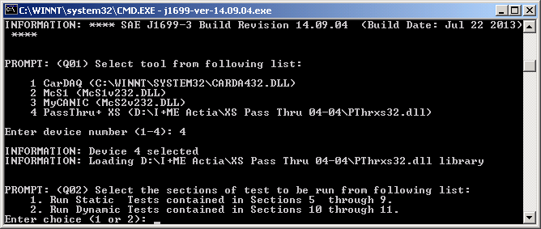
Figure 1 – Sample Test Selection Screen

Enter “1” for Static tests.
Next the user will be prompted to enter some vehicle information and select the compliance test type (as depicted in Figure 2).
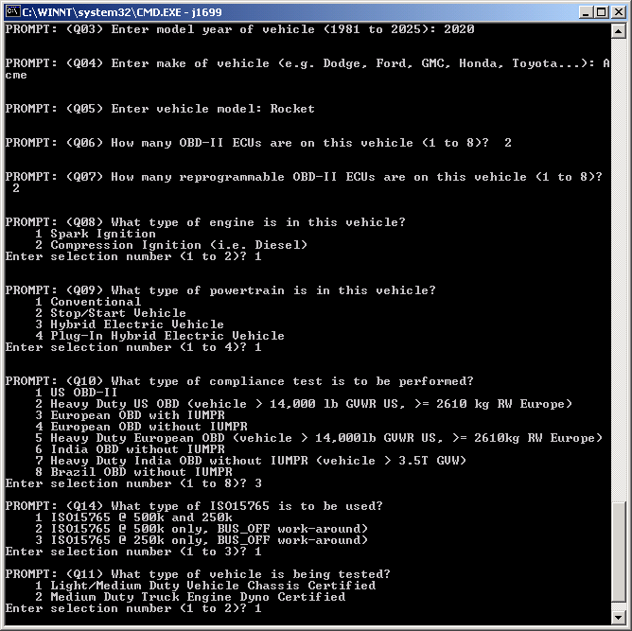
Figure 2 – Sample Vehicle Configuration Screen (Static Test)

Enter the appropriate responses for your specific vehicle configuration and compliance test type.

Next the user is prompted with the option to disable tester present message for ISO15765 protocol vehicles (All other protocols will send tester present messages regardless of the response to this prompt). ISO15765 vehicles should not need periodic tester present messages but some are failing without them. When this problem is overcome this prompt will be removed.
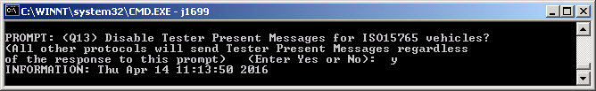
Then the user will be presented with a summary of the information entered so far and prompted to enter some optional user information (as depicted in Figure 3).
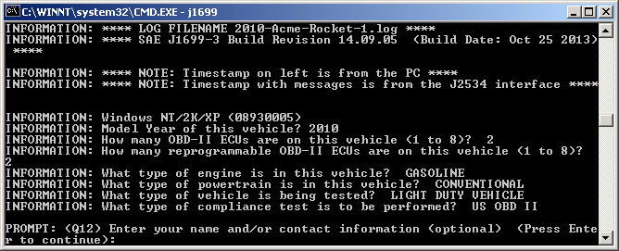
Figure 3 – Sample User Information Screen (Static Test)

Continue on by following the on-screen instructions to complete the remainder of the test.

The Static Tests 5.1-9.18

The first instruction is to turn the key off for at least 30 seconds. After the key has been off for the required amount of time, press the enter key. Next turn the key on without cranking the engine then press enter. The MIL should have been lit for at least 15 seconds, if so enter ‘Y’ at the prompt. Otherwise enter ‘N’.
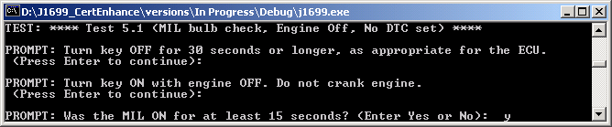
Figure 4 - Test 5.1 User Input Prompts
The next user instruction is at Test 5.8 and it is to start the engine and let it idle for 1 minute, then press the enter key. Note that the user needs to take steps to ensure that the engine actually is idling for that time because some engine controls (electric hybrid) can stop and start the engine regardless of the ignition staying on.
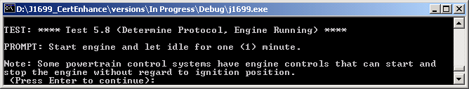
Figure 5 – Test 5.8 User Input Prompt
At Test 6.1 the user is instructed to disconnect a sensor that will cause a fault (which will light the MIL in two drive cycles). After the sensor is disconnected, press the enter key. Next start the engine and let it idle, then press the enter key.
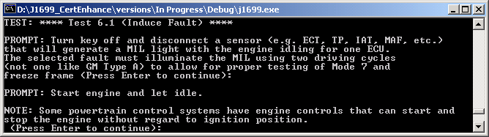
Figure 6 – Test 61 User Input Prompts

Test 6.6 is for Europe, India and Brazil only. Turn the key off for at least 30 seconds, with the sensor still disconnected, then press the enter key. Next start the engine and let it idle for at least 1 minute (or however long it takes to set a pending DTC), then press the enter key.
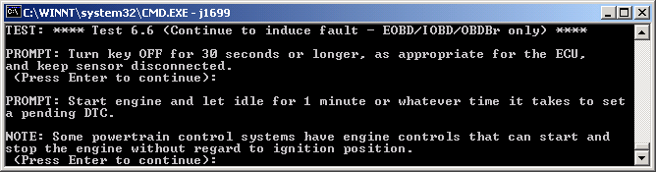
Figure 7 – Test 6.6 User Input Prompts

For Test 7.1, turn the key off for at least 30 seconds, with the sensor still disconnected, then press the enter key. Next start the engine and let it idle for at least 1 minute (or however long it takes to set a pending DTC), then press the enter key.
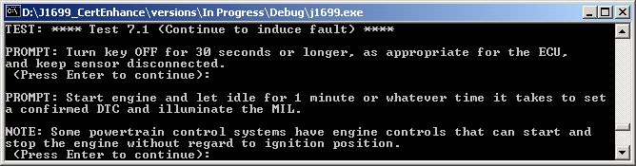
Figure 8 – Test 7.1 User Input Prompts
By Test 7.4, a DTC should be stored and the MIL illuminated. If it is, enter ‘Y’. If it is not illuminated enter ‘N’.
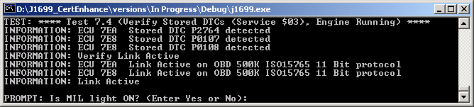
Figure 9 – Test 7.4 User Input Prompt

At Test 8.1, turn the key off for at least 30 seconds, then press the enter key. Reconnect the sensor and press the enter key. Start the engine and idle for however long it takes for the repaired malfunction to be detected, then press the enter key. Turn the key off for at least 30 seconds (to complete one drive cycle) and press the enter key. Finally, start the engine and idle for however long it takes to detect that there is no malfunction and press the enter key.
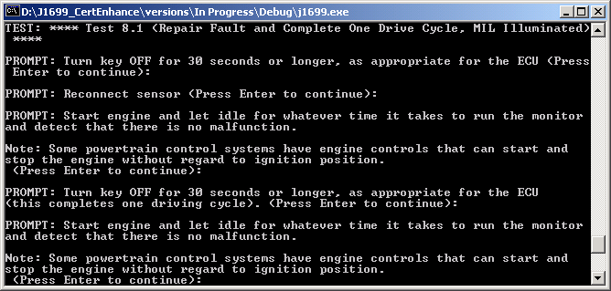
Figure 10 – Test 8.1 User Input Prompts

For Test 8.4, the MIL should be illuminated. If it is, enter ‘Y’. If it is not illuminated enter ‘N’.
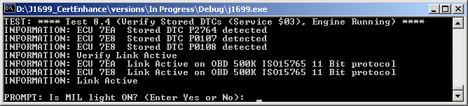
Figure 11 – Test 8.4 User Input Prompt
At Test 9.1, turn the key off for at least 30 seconds (to complete a second drive cycle) and press the enter key. Start the engine (starting a third drive cycle) and idle for at least 1 minute or however long it takes to detect that there is no malfunction then press the enter key. Turn the key off for at least 30 seconds (to complete the third drive cycle) and press the enter key. Start the engine (starting a fourth drive cycle), idle for at least 1 minute, then press the enter key. By now the MIL should no longer be illuminated. If it is not, enter ‘Y’. If it is still illuminated, enter ‘N’ and more drive cycles may be performed until it turns off.
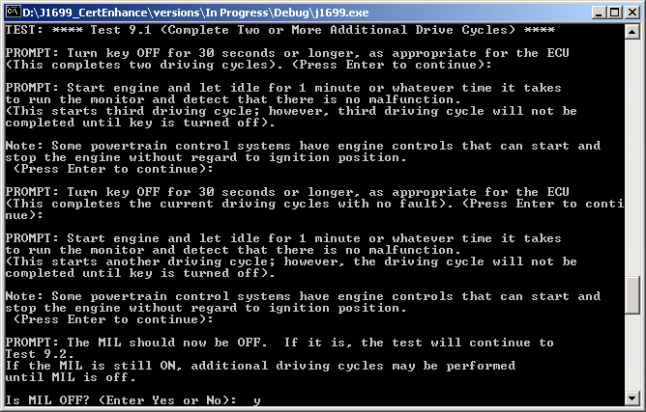
Figure 12 – Test 9.1 User Input Prompts

At Test 9.7, if SID $A is supported, the user should choose to perform the CARB drive cycle for permanent DTCs. If the user chooses not to perform the drive cycle portion, the test skips to Test 9.23.
For Test 9.8, with engine and ignition off, disconnect a sensor that is tested continuously and will set a fault, which quickly (< 10 seconds of idle) generates a single DTC and turns on the MIL. After the sensor is disconnected press the enter key. Start the engine and idle for at least 1 minute, then press the enter key. Turn the ignition off for at least 30 seconds, keeping the sensor disconnected, and press the enter key. Start the engine and idle for at least 1 minute, or however long it takes to set the confirmed DTC and illuminate the MIL, and press the enter key. Turn the ignition off for at least 30 seconds, keeping the sensor disconnected (completing the drive cycle and allowing a permanent code to be set), and press the enter key. Finally, turn the ignition on without cranking the engine. Press the enter key.
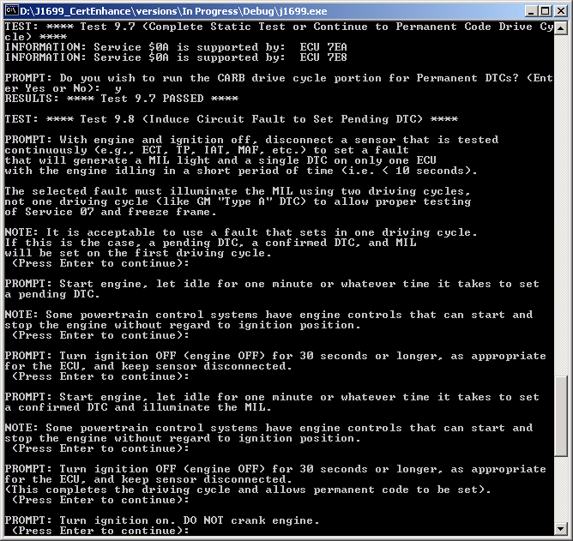
Figure 13 – Test 9.7 & 9.8 User Input Prompts
At Test 9.12, turn the ignition off for at least 30 seconds then press the enter key. Reconnect the sensor which was disconnected at Test 9.8 and press the enter key. Then turn the ignition on without starting the engine and press the enter key.
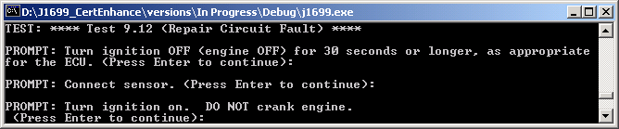
Figure 14 – Test 9.12 User Input Prompts

For Test 9.16, start the engine and idle for at least 1 minute or however long it takes to detect that there is no longer a malfunction, then press the enter key. Turn the ignition off for at least 30 seconds (completing one drive cycle with no fault) and press the enter key. Then start the engine and remain idling until the drive cycle test (9.19). Press the enter key.
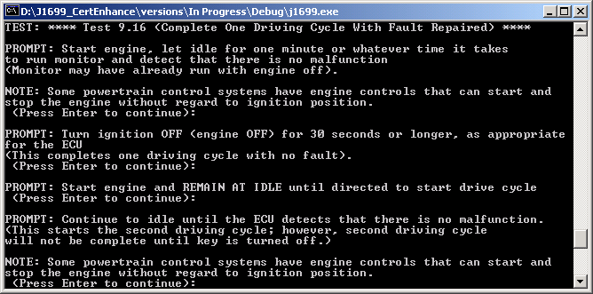
Figure 15 – Test 9.16 User Input Prompts

Test 9.19 – The Permanent Code Drive Cycle
When running Test 9.19, a screen (similar to the one in Figure 16 will be displayed and you must now drive a CARB Drive Cycle, but without the temperature and pressure restrictions as incrementing the OBD Condition Counter is not a requirement).
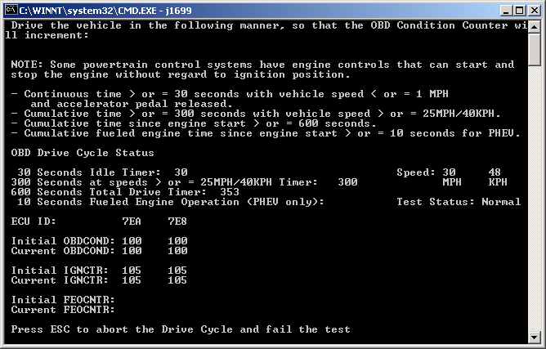
Figure 16 – Permanent Code Drive Cycle Screen

IT IS SUGGESTED THAT YOU COMPLETE 30 SECONDS CONTINUOUS IDLE FIRST!!!

Once the idle timer has reached 30 seconds (< 1 mph or 450 RPM), you can begin to drive the vehicle. To complete the remainder of the CARB Drive Cycle, you must have accumulated at least 300 seconds of driving at speeds in excess of 25 mph (40 kph) (1150 RPM) and have accumulated at least 600 seconds of engine run time. Towards the end of this drive cycle, the OBD Condition Counter on the vehicle may increment, ending the test. The OBD Condition Counter is not required to increment, so if it does not change the test will end approximately 20 seconds after the three timers have reached their minimum acceptable values.

The Fueled Engine Operation time and FEOCNTR display values only for Plug-in Hybrid Electric Vehicles and even then have no effect on the outcome of this test.

At the right hand side of the screen is the “Test Status:”. This will either display ‘Normal’ or ‘FAILURE’. When ‘FAILURE’ is displayed, it indicates that an error has been detected (typically caused by an early, late, missing, or invalid response) and the associated message traffic and reason will be noted in the log file. Once a ‘FAILURE’ has been detected it cannot be cleared and a user abort or completion of the test will result in the associated test being labeled as ‘Failed’.

If you are unable to successfully complete the CARB Drive Cycle, you can press the <ESC> key to abort the test and record a FAILURE in the log file.

At the end of the CARB Drive Cycle, you will be prompted to pull over and turn the key off. Simply follow the on-screen instruction for the remainder of the test.

The End of the Static Tests
At Test 9.20, turn the ignition on and start the engine, then press the enter key.
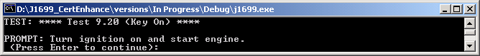
Figure 17 – Test 9.20 User Input Prompt

Before test 9.23, the user may exit Test 9 or continue and clear all diagnostic information. If clearing of diagnostic information is to be skipped, enter ‘N’. If diagnostic information is to be cleared, enter ‘Y’ and the user will be further prompted whether the codes should be cleared with the engine running. If codes are to be cleared with engine running, enter ‘Y’. If codes are to be cleared with engine off, enter ‘N’ and the user will be further prompted to turn the key off for at least 30 seconds and press the enter key. Then turn the ignition on without cranking the engine and press the enter key.
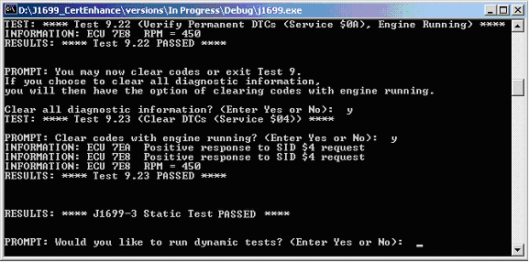
Figure 18 – Test 9.22,23 User Input Prompts
At the end of the Static Tests, the J1699-3 application will prompt to see it you want to continue on with the Dynamic Tests. Entering a “Y” will command the J1699-3 application to begin the Dynamic Test phase using the vehicle configuration information you provided at the start of the Static Tests. Otherwise, the J1699-3 application will prompt the user for a closing comment then log the test results and terminate (similar to Figure 19).
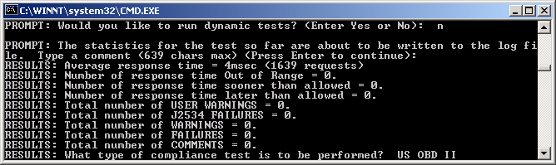
Figure 19 - Static Test Results

Dynamic Test Overview
The Dynamic Tests consists of two sections, Test 10 and Test 11. You will complete Test 10 during one session and complete Test 11 in a separate session(s). Since multiple cold starts may be required to complete Test 11, multiple sessions may be used.

The J1699-3 application generates a log file. This log file contains information that will allow you to bypass Test 10 once you have successfully completed it. If you are resuming the Manufacturer Specific Drive Cycle, make sure you use the same log file. (This means entering the same file name if the VIN in the ECU is invalid.) If you type in a different log file name, the I/M Ready flags that were completed in Test 10 will be cleared and you will have to repeat Test 10. If Test 10 is not successfully completed, the results will be stored in a temporary log file whose name is “J16xx.tmp” – where the xx is hex number assigned by the operating system. This temporary file follows the same format as a normal J1699-3 log file and may provide valuable information about why Test 10 failed.

Specific conditions are needed to meet the OBD and EVAP conditions. The J1699-3 application checks whether you have incremented the OBD and EVAP condition counters (if supported) before you can successfully complete this testing. (The CARB definitions are included at the end of this document). Make sure you meet these conditions before starting:
Ambient temperature > 20F for OBD; Ambient > 40F and < 95F for EVAP
Altitude < 8000 feet (Any road east of the Mississippi) for both OBD and EVAP
Startup Coolant > 40F and < 95F for EVAP
Startup Coolant <= IAT + 12F for EVAP

During Test 10, you will be directed to perform a CARB Drive Cycle (30 seconds at idle, followed by 300 seconds driving at speeds greater than 25 mph, and a total engine run time of at least 600 seconds). The CARB Drive Cycle will take a minimum of 600 seconds, but may take longer depending upon how you drive. You will be prompted when you have completed the CARB Drive Cycle in Test 10.

During Test 11, you will be directed to perform a Manufacturer Specific Drive Cycle. During this drive cycle, you can use the J1699-3 application to monitor your progress, but this is not required. If you choose to exit the Manufacturer Specific Drive Cycle Monitor Screen, you can re-enter it by re-running the J1699-3 application and selecting ‘Dynamic Tests’. You may enter and exit the Manufacturer Specific Drive Cycle Monitor Screen as often as is needed. Once the J1699-3 application detects that the Manufacturer Specific Drive Cycle has been completed, it will automatically continue on with the rest of the J1699-3 test.

Dynamic Test Sample Run
This sample will highlight some areas of the Dynamic Test by providing sample screen shots as well as some detailed instruction. The entire Dynamic Test is NOT included here, as the majority of the test requires minimal interaction by the user.

Starting the Dynamic Test
Launch J1699-3 application (named j1699-ver-xx.yy.zz.exe; where xx.yy.zz is the associated version number of the software release).

After starting the J1699-3 application, the user is prompted select theJ2534-1 Interface. Once this is done, the user will be prompted to select the tests to be run (as depicted in Figure 20).
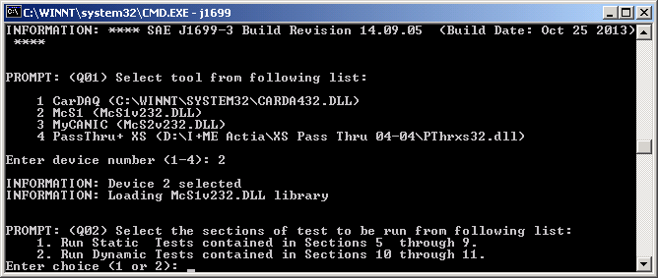
Figure 20 – Sample Test Selection Screen

Enter “2” for Dynamic tests.
Next the user will be prompted to enter some vehicle information, select the compliance test type, and then enter some optional user information (as depicted in Figure 21).
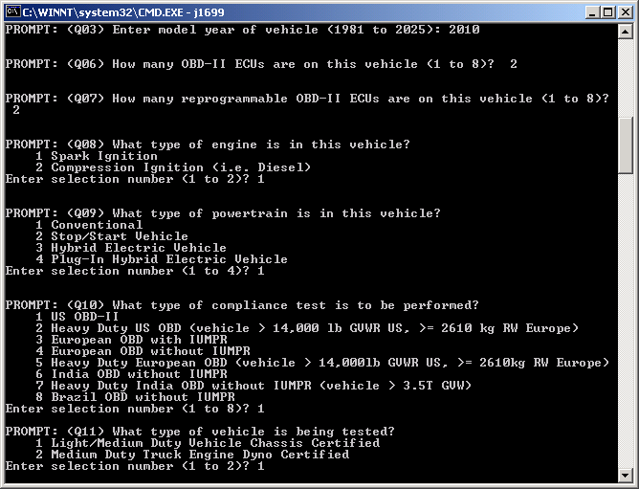
Figure 21 – Sample Vehicle Configuration Screen (Dynamic Test)

Enter the appropriate responses for your specific vehicle configuration and compliance test type. Then turn the key on and press enter as instructed.
If the ECU has a VIN flashed in, the J1699-3 application will automatically find the VIN and create a log file using the VIN.

If the vehicle does not support VIN or the VIN is invalid, you will be prompted to select a log file name (as depicted in Figure 22).

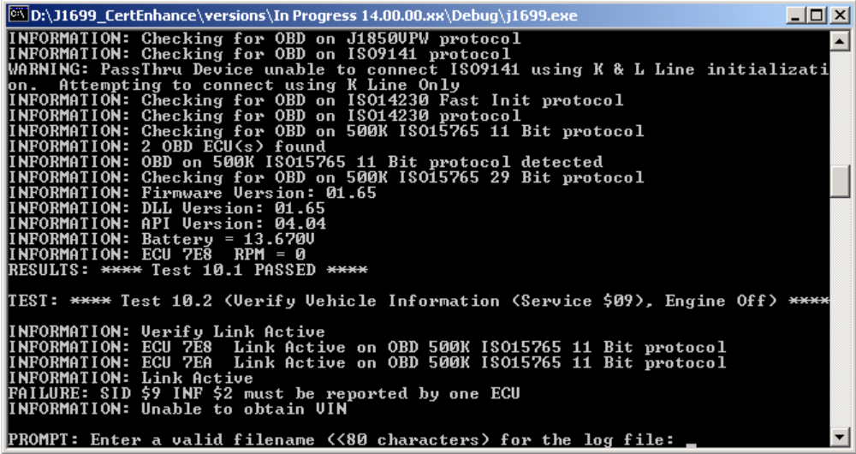
Figure 22 – Vehicle does not support VIN
Once the log file name has been established, the J1699-3 application will determine if Test 10 has been completed. If it has, then Test 11 will automatically be started. Otherwise, the remainder of Test 10 will be completed.

Test 10.1- 10.10
At Test 10.1, the user is prompted to turn on the key without starting the engine then press the enter key.
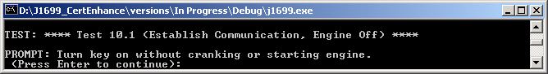
Figure 23 – Test 10.1 User Input Prompt

For Test 10.10, turn ignition off for 1 minute and press the enter key. Then turn the ignition on, starting the engine, and press the enter key.
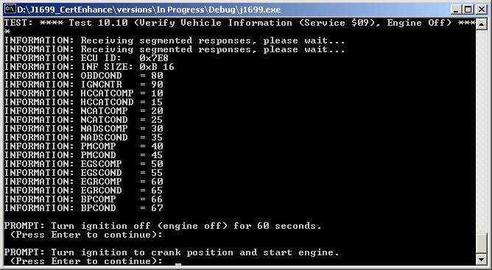
Figure 24 – Test 10.10 User Input Prompt

Test 10.12 – The CARB Drive Cycle
When running Test 10.12, a screen (similar to the one in Figure25 or Figure 26 if SID $1 PID $1C is $22) will be displayed and you must now drive a CARB Drive Cycle.

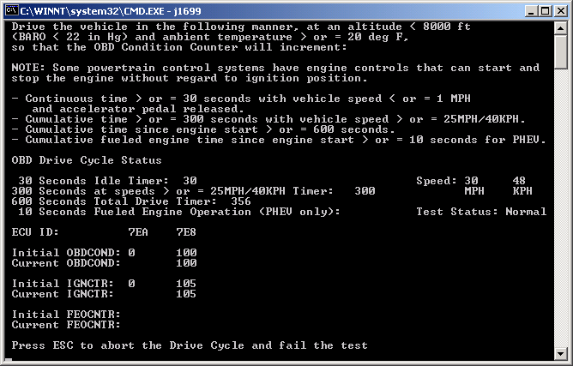
Figure 25 – CARB Drive Cycle Screen (Vehicle Speed)
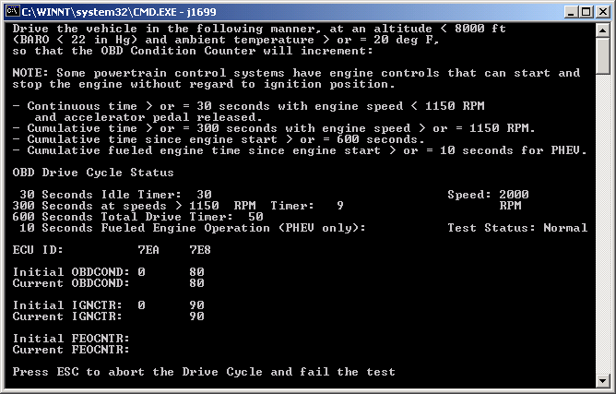
Figure 26 – CARB Drive Cycle Screen (Engine Speed)

IT IS SUGGESTED THAT YOU COMPLETE 30 SECONDS CONTINUOUS IDLE FIRST!!!

Once the idle timer has reached 30 seconds, you can begin to drive the vehicle. To complete the remainder of the CARB Drive Cycle, you must have accumulated at least 300 seconds of driving at speeds in excess of 25 mph (40 kph) (1150 RPM) and have accumulated at least 600 seconds of engine run time. Towards the end of this drive cycle, the OBD Condition Counter on the vehicle will automatically increment, ending the test.

The Fueled Engine Operation time and FEOCNTR display values only for Plug-in Hybrid Electric Vehicles. FEOCNTR is displayed for information only, it does not affect the outcome of Test 10.12 (it’s value is tested in 10.14).

At the right hand side of the screen is the “Test Status:”. This will either display ‘Normal’ or ‘FAILURE’. When ‘FAILURE’ is displayed, it indicates that an error has been detected (typically caused by an early, late, missing, or invalid response) and the associated message traffic and reason will be noted in the log file. Once a ‘FAILURE’ has been detected it cannot be cleared and a user abort or completion of the test will result in the associated test being labeled as ‘Failed’.

If you are unable to successfully complete the CARB Drive Cycle, you can press the <ESC> key to abort the test and record a FAILURE in the log file.

At the end of the CARB Drive Cycle, you will be prompted to pull over and idle BUT DO NOT TURN THE KEY OFF.

The J1699-3 application will evaluate several engine conditions that require an engine running condition and will then move on to Test 11. The log file for the Dynamic tests will contain information that will allow you to bypass Test 10 once you have successfully completed it.

Test 11.2 – The Manufacturer Specific Drive Cycle
When Test 11 starts, a screen (similar to the one in Figure 27) will be displayed. You can choose to use the J1699-3 application to monitor the status of the vehicle, but this is NOT required. If you select ‘N’, then the J1699-3 application will terminate and you should perform the drive cycle. After completing the drive cycle, re-run the J1699-3 application and it will automatically proceed from this point.

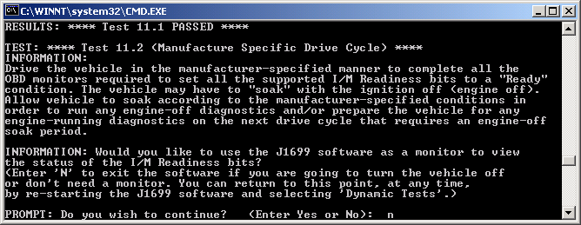
Figure 27 – Prompt to begin the Manufacturer Specific Drive Cycle

If you select ‘Y’ to monitor using the J1699-3 application, you will see the current vehicle status (as depicted in Figure 28 for INF $B vehicle or Figure 29 for INF $8 vehicles).

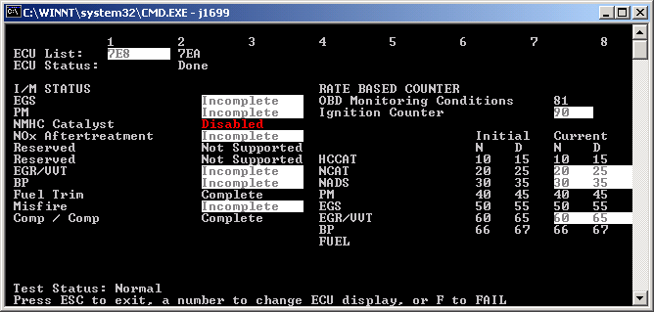
Figure 298 –Manufacturer Specific Drive Cycle Monitor Screen (INF $B)
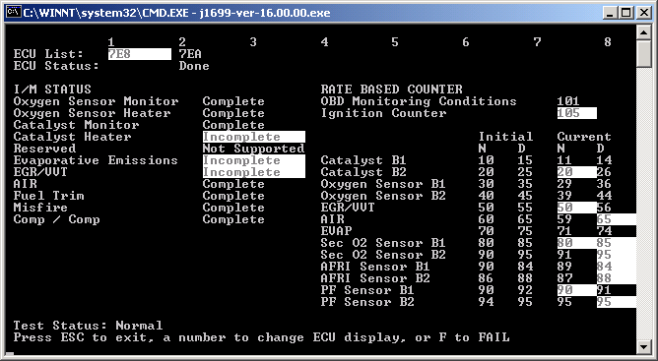
Figure 309 –Manufacturer Specific Drive Cycle Monitor Screen (INF $8)

The ECUs are listed at the top of this screen. The highlighted ECU address identifies the currently selected ECU. The display will contain that ECU’s associated information. You can change between ECUs by entering the number (1 thru 8) that corresponds to the desired ECU. Also along the top of this screen is the corresponding ECU’s status (either ‘Done’ or blank).

ECU’s whose status is ‘Done’ have completed all the necessary monitor changes. ECU’s whose status is blank will have incomplete monitors highlighted or disabled monitors noted in red text. This will aid you in determining which items are left to complete. Unsupported Counters do not display a value and do not affect the test. Remember, you must drive in the manner prescribed by the manufacturer to complete all the appropriate In-Use Performance Tracking counters and set all the supported I/M Readiness Bits to a ‘Ready’ condition.

At the bottom of the screen is the “Test Status:”. This will either display ‘Normal’ or ‘FAILURE’. When ‘FAILURE’ is displayed, it indicates that an error has been detected (typically caused by an early, late, missing, or invalid response) and the associated message traffic and reason will be noted in the log file. Once a ‘FAILURE’ has been detected it cannot be cleared and a user abort or completion of the test will result in the associated test being labeled as ‘Failed’.

During this drive cycle, the J1699-3 application will also check for Pending or Confirmed DTCs. If any DTCs are detected, “DTC Detected” will be displayed next to the Test Status and will remain there as long as a DTC is present. This feature is intended to be an aid to the operator, as some DTCs may inhibit In-Use Performance Tracking counters or I/M Readiness Bits from changing. The presence of a DTC is not an evaluation criterion for this test and, as such, will not directly cause this test to fail.

From the Manufacturer Specific Drive Cycle Monitor screen, you can select “ESC” to exit the J1699-3 application. You can return to this exact point by simply selecting the “Dynamic Tests” from the test selection menu when the J1699-3 application is first started. Otherwise, you can remain in the J1699-3 application and continue to monitor the status while you drive in the prescribed manner.

If you are unable to successfully complete the CARB Drive Cycle, you can press the <ESC> key to abort the test and record a FAILURE in the log file.

When re-entering the Manufacturer Specific Drive Cycle Monitor screen, the CARB Drive Cycle Timers will be displayed on the line above the Test Status. These timers are for informational purposes only. They act as an aid to an operator who may wish to perform a CARB Drive Cycle, but there is NO evaluation on the timing of an OBDCOND monitor increment. On this line, “Cont. Idle (Sec.):” represents the number of seconds of continuous idle time – this counter stops after there has been 30 seconds. “At Speed (Sec.):” represents the number of seconds the vehicle has been traveling at speeds greater than 25 MPH (40 KPH) – this counter stops after there has been a total of 300 seconds. “Run Time (Sec.):” represents the total number of seconds of engine run time – this counter will continue to increment so long as the vehicle is in operation. It should be noted that that the vehicle state, from the time the engine was started until the Manufacturer Specific Drive Cycle Monitor screen is displayed shall assumed to be at ‘Idle’ so long as the vehicle speed is 0 when the Manufacturer Specific Drive Cycle Monitor screen is displayed. If the vehicle speed is not 0 when this screen is displayed, then no assumption shall be made regardless of the actual state of the vehicle during that time period.

Remember to use the same log file name when re-entering the test OTHERWISE, THE I/M READINESS INFORMATION WILL BE CLEARED AND YOU WILL BE REQUIRED TO START OVER. The J1699-3 application will automatically leave the monitor screen when it has detected that the vehicle has successfully changed the appropriate In-Use Performance Tracking counters and set all the supported I/M Readiness bits to a ‘Ready’ condition.

Continue on by following the on-screen instructions to complete the remainder of the test.

The last user prompt is Test 11.3. After pulling over to a safe spot, turn off the ignition for at least 30 seconds, and press the enter key. Turn on the ignition without starting the engine then press the enter key.
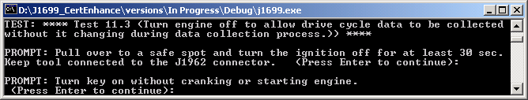
Figure 31 – Test 11.3 User Input Prompt

At the end of the Dynamic Tests the J1699-3 application will prompt the user for a closing comment, then log the test results and terminate (similar to Figure 31).
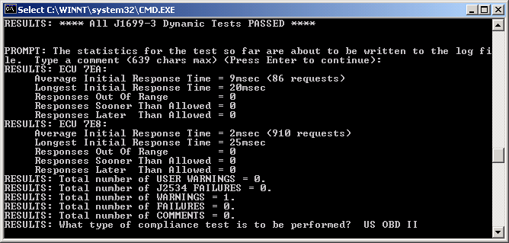
Figure 321 – Dynamic Test Results

Sample Log File
The following is an extract from a Static Test log file for an ISO 14230 vehicle that did not support Permanent DTCs:

+000010ms INFORMATION: Thu Jan 06 10:52:42 2011

+000010ms INFORMATION: **** LOG FILENAME 2004-Engineering-Test-1.log ****
+000010ms INFORMATION: **** SAE J1699-3 Build Revision 14.04.01 (Build Date: Jan 6 2011) ****

+000010ms INFORMATION: **** NOTE: Timestamp on left is from the PC ****
+000010ms INFORMATION: **** NOTE: Timestamp with messages is from the J2534 interface ****

+000010ms INFORMATION: Windows NT/2K/XP (08930005)
+000010ms INFORMATION: Device = CarDAQ
+000020ms INFORMATION: ProtocolsSupported = CAN,ISO9141,ISO14230,ISO15765,J1850VPW,J1850PWM,
+000000ms INFORMATION: Device = McS1
+000010ms INFORMATION: ProtocolsSupported = CAN,ISO9141,ISO14230,ISO15765,J1850VPW,J1850PWM,
+000010ms INFORMATION: Device = PassThru+ XS
+000010ms INFORMATION: ProtocolsSupported = CAN,ISO9141,ISO14230,ISO15765,J1850VPW,J1850PWM,

+000050ms PROMPT: Select tool from following list:

1 CarDAQ (C:\WINNT\SYSTEM32\CARDA432.DLL)
2 McS1 (McS1v232.DLL)
3 PassThru+ XS (D:\I+ME Actia\XS Pass Thru 04-04\PThrxs32.dll)

Enter device number (1-3):
+000010ms INFORMATION: Device 2 selected
+000000ms INFORMATION: Loading McS1v232.DLL library

+000000ms INFORMATION: Model Year of this vehicle? 2004
+000010ms INFORMATION: How many OBD-II ECUs are on this vehicle (1 to 8)? 2
+000010ms INFORMATION: How many reprogrammable, OBD-II ECUs are on this vehicle (1 to 8)? 2
+000010ms INFORMATION: Does the vehicle use compression ignition (i.e. diesel)? NO
+000010ms INFORMATION: Is this a hybrid or stop-start vehicle? NO
+000010ms INFORMATION: Selected type of compliance test: US OBD II

+001011ms PROMPT: Enter your name and/or contact information (optional) (Press Enter to continue):

+000030ms TEST: **** Test 5.1 (MIL bulb check, Engine Off, No DTC set) ****

+000141ms PROMPT: Turn key OFF for 30 seconds or longer, as appropriate for the ECU.
(Press Enter to continue):

+000150ms PROMPT: Turn key ON with engine OFF. Do not crank engine.
(Press Enter to continue):

+000330ms PROMPT: Was the MIL ON for at least 15 seconds? (Enter Yes or No): Y

+000010ms RESULTS: **** Test 5.1 PASSED ****

+000010ms TEST: **** Test 5.2 (Determine Protocol, Ignition On, Engine Off) ****
+000010ms INFORMATION: Checking for OBD on J1850PWM protocol
+000000ms NETWORK: REQ MSG: J1850PWM 61 6A F1 01 00
+000000ms NETWORK: TX MSG: 40880705usec J1850PWM 61 6A F1 01 00
+000020ms INFORMATION: Checking for OBD on J1850VPW protocol
+000000ms NETWORK: REQ MSG: J1850VPW 68 6A F1 01 00
+000000ms NETWORK: TX MSG: 41633486usec J1850VPW 68 6A F1 01 00
+000020ms INFORMATION: Checking for OBD on ISO9141 protocol
+000000ms NETWORK: REQ MSG: ISO9141 68 6A F1 01 00
+000000ms NETWORK: TX MSG: 47724090usec ISO9141 68 6A F1 01 00
+005027ms INFORMATION: Checking for OBD on ISO14230 Fast Init protocol
+000561ms INFORMATION: ECU $11 Keyword 1 = $E9 Keyword 2 = $8F
+000000ms NETWORK: REQ MSG: ISO14230 C2 33 F1 01 00
+000000ms NETWORK: TX MSG: 53977085usec ISO14230 C2 33 F1 01 00
+000000ms NETWORK: RX MSG: 54008631usec ISO14230 Start of Message
+000000ms NETWORK: RX MSG: 54064401usec ISO14230 86 F1 18 41 00 80 00 00 01
+000010ms NETWORK: EOM: 53977085 usec, SOM: 54008631 usec, DELTA: 31546 usec
+000000ms NETWORK: RX MSG: 54096743usec ISO14230 Start of Message
+000000ms NETWORK: RX MSG: 54152604usec ISO14230 86 F1 11 41 00 BE 3F B8 13
+000010ms NETWORK: EOM: 54064401 usec, SOM: 54096743 usec, DELTA: 32342 usec
+000260ms INFORMATION: 2 OBD ECU(s) found
+000010ms INFORMATION: OBD on ISO14230 Fast Init protocol detected
+005018ms INFORMATION: Checking for OBD on ISO14230 protocol
+005017ms INFORMATION: Checking for OBD on 500K ISO15765 11 Bit protocol
+000000ms NETWORK: REQ MSG: ISO15765 00 00 07 DF 01 00
+000020ms INFORMATION: Checking for OBD on 500K ISO15765 29 Bit protocol
+000000ms NETWORK: REQ MSG: CAN 18 DB 33 F1 02 01 00 00 00 00 00 00
+000551ms INFORMATION: ECU $11 Keyword 1 = $E9 Keyword 2 = $8F
+000020ms INFORMATION: Firmware Version: 02.26
+000000ms INFORMATION: DLL Version: 02.26
+000010ms INFORMATION: API Version: 04.04
+000020ms INFORMATION: Battery = 13.850V
+000000ms NETWORK: REQ MSG: ISO14230 C2 33 F1 01 0C
+000000ms NETWORK: TX MSG: 72912080usec ISO14230 C2 33 F1 01 0C
+000000ms NETWORK: RX MSG: 72943502usec ISO14230 Start of Message
+000000ms NETWORK: RX MSG: 72986887usec ISO14230 84 F1 11 41 0C 00 00
+000010ms NETWORK: EOM: 72912080 usec, SOM: 72943502 usec, DELTA: 31422 usec
+000000ms INFORMATION: ECU 11 RPM = 0
+000000ms INFORMATION: VerifyVehicleState - Expected State: Off, RPM: 0, Hybrid: No
+000010ms RESULTS: **** Test 5.2 PASSED ****

+000010ms TEST: **** Test 5.3 (Clear DTCs (Service $04), Engine Off) ****
+000000ms NETWORK: REQ MSG: ISO14230 C1 33 F1 04
+000000ms NETWORK: TX MSG: 73658080usec ISO14230 C1 33 F1 04
+000000ms NETWORK: RX MSG: 73689288usec ISO14230 Start of Message
+000000ms NETWORK: RX MSG: 73714149usec ISO14230 81 F1 18 44
+000000ms NETWORK: EOM: 73658080 usec, SOM: 73689288 usec, DELTA: 31208 usec
+000000ms NETWORK: RX MSG: 73746395usec ISO14230 Start of Message
+000000ms NETWORK: RX MSG: 73771256usec ISO14230 81 F1 11 44
+000010ms NETWORK: EOM: 73714149 usec, SOM: 73746395 usec, DELTA: 32246 usec
+002012ms INFORMATION: ECU 18 Positive response to SID $4 request
+000000ms INFORMATION: ECU 11 Positive response to SID $4 request
+000000ms NETWORK: REQ MSG: ISO14230 C2 33 F1 01 0C
+000000ms NETWORK: TX MSG: 76446112usec ISO14230 C2 33 F1 01 0C
+000000ms NETWORK: RX MSG: 76477390usec ISO14230 Start of Message
+000000ms NETWORK: RX MSG: 76520780usec ISO14230 84 F1 11 41 0C 00 00
+000000ms NETWORK: EOM: 76446112 usec, SOM: 76477390 usec, DELTA: 31278 usec
+000000ms INFORMATION: ECU 11 RPM = 0
+000000ms INFORMATION: VerifyVehicleState - Expected State: Off, RPM: 0, Hybrid: No
+000010ms RESULTS: **** Test 5.3 PASSED ****

.
. [NOTE: TESTS 5.4 thru 9.5 ARE NOT PICTURED IN THIS EXAMPLE]
.

+000010ms TEST: **** Test 9.6 (Verify Permanent DTCs (Service $0A), Engine Running) ****
+000000ms NETWORK: REQ MSG: ISO14230 C2 33 F1 01 0C
+000000ms NETWORK: TX MSG: 811166080usec ISO14230 C2 33 F1 01 0C
+000000ms NETWORK: RX MSG: 811197401usec ISO14230 Start of Message
+000000ms NETWORK: RX MSG: 811240882usec ISO14230 84 F1 11 41 0C 0F A0
+000010ms NETWORK: EOM: 811166080 usec, SOM: 811197401 usec, DELTA: 31321 usec
+000000ms INFORMATION: ECU 11 RPM = 1000
+000000ms INFORMATION: VerifyVehicleState - Expected State: Running, RPM: 1000, Hybrid: No
+000010ms RESULTS: **** Test 9.6 PASSED ****

+000010ms TEST: **** Test 9.7 (Complete Static Test or Continue to Permanent Code Drive Cycle) ****
+000020ms WARNING: Service $0A was not supported by any ECU, therefore
the Permanent Code Drive Cycle was not tested.

+000000ms RESULTS: **** Test 9.7 PASSED ****

+002163ms PROMPT: You may now clear codes or exit Test 9.
If you choose to clear all diagnostic information,
you will then have the option of clearing codes with engine running.

Clear all diagnostic information? (Enter Yes or No): N

+003435ms PROMPT: Turn key OFF (Press Enter to continue):

+000010ms RESULTS: **** All J1699-3 Static Tests PASSED ****

+002484ms PROMPT: Would you like to run dynamic tests? (Enter Yes or No): N

+000050ms RESULTS: ECU 18:
Average Initial Response Time = 5msec (616 requests)
Longest Initial Response Time = 21msec
Responses Out Of Range = 0
Responses Sooner Than Allowed = 0
Responses Later Than Allowed = 0
+000050ms RESULTS: ECU 11:
Average Initial Response Time = 6msec (1174 requests)
Longest Initial Response Time = 19msec
Responses Out Of Range = 0
Responses Sooner Than Allowed = 0
Responses Later Than Allowed = 0
+000000ms RESULTS: Total number of USER ERRORS = 0.
+000010ms RESULTS: Total number of J2534 FAILURES = 0.
+000000ms RESULTS: Total number of WARNINGS = 1.
+000010ms RESULTS: Total number of FAILURES = 0.
+000010ms RESULTS: Selected type of compliance test: US OBD II

Table of Figures

Figure 1 – Sample Test Selection Screen 11
Figure 2 – Sample Vehicle Configuration Screen (Static Test) 12
Figure 3 – Sample User Information Screen (Static Test) 13
Figure 4 - Test 5.1 User Input Prompts 13
Figure 5 – Test 5.8 User Input Prompt 13
Figure 6 – Test 61 User Input Prompts 14
Figure 7 – Test 6.6 User Input Prompts 14
Figure 8 – Test 7.1 User Input Prompts 14
Figure 9 – Test 7.4 User Input Prompt 15
Figure 10 – Test 8.1 User Input Prompts 15
Figure 11 – Test 8.4 User Input Prompt 15
Figure 12 – Test 9.1 User Input Prompts 16
Figure 13 – Test 9.7 & 9.8 User Input Prompts 17
Figure 14 – Test 9.12 User Input Prompts 18
Figure 15 – Test 9.16 User Input Prompts 18
Figure 16 – Permanent Code Drive Cycle Screen 19
Figure 17 – Test 9.20 User Input Prompt 20
Figure 18 – Test 9.22,23 User Input Prompts 20
Figure 19 - Static Test Results 21
Figure 20 – Sample Test Selection Screen 23
Figure 21 – Sample Vehicle Configuration Screen (Dynamic Test) 24
Figure 22 – Vehicle does not support VIN 25
Figure 23 – Test 10.1 User Input Prompt 26
Figure 24 – Test 10.10 User Input Prompt 26
Figure 25 – CARB Drive Cycle Screen (Vehicle Speed) 27
Figure 26 – CARB Drive Cycle Screen (Engine Speed) 27
Figure 27 – Prompt to begin the Manufacturer Specific Drive Cycle 29
Figure 28 –Manufacturer Specific Drive Cycle Monitor Screen (INF $B) 29
Figure 29 –Manufacturer Specific Drive Cycle Monitor Screen (INF $8) 30
Figure 30 – Test 11.3 User Input Prompt 31
Figure 31 – Dynamic Test Results 32

Appendix A: OBD and EVAP Drive Condition Definitions

As a guide, the OBD and EVAP drive condition definitions are as follows (please consult the official regulation for the current requirements):

From CARB Specifications:
(4.3) Denominator Specifications
(4.3.1) Definition: The denominator is defined as a measure of the number of times a vehicle has been operated as defined in (d)(4.3.2).
(4.3.2) Specifications for incrementing:
(A) The denominator, when incremented, shall be incremented by an integer of
one. The denominator may not be incremented more than once per driving cycle.
(B) The denominator for each monitor shall be incremented within ten seconds if
and only if the following criteria are satisfied on a single driving cycle:
(i) Cumulative time since engine start is greater than or equal to 600
seconds while at an elevation of less than 8,000 feet above sea level and
at an ambient temperature of greater than or equal to 20 degrees Fahrenheit;
(ii) Cumulative vehicle operation at or above 25 miles per hour occurs for
greater than or equal to 300 seconds while at an elevation of less than
8,000 feet above sea level and at an ambient temperature of greater than
or equal to 20 degrees Fahrenheit;
(iii) Continuous vehicle operation at idle (i.e., accelerator pedal released by
driver and vehicle speed less than or equal to one mile per hour) for
greater than or equal to 30 seconds while at an elevation of less than
8,000 feet above sea level and at an ambient temperature of greater than
or equal to 20 degrees Fahrenheit;
(C) In addition to the requirements of section (d)(4.3.2)(B) above, the secondary
air system monitor denominator(s) shall be incremented if and only if
commanded “on” operation of the secondary air system occurs for a time
greater than or equal to ten seconds. For purposes of determining this
commanded “on” time, the OBD II system may not include time during
intrusive operation of the secondary air system solely for the purposes of
monitoring;
(D) In addition to the requirements of section (d)(4.3.2)(B) above, the
evaporative system monitor denominator(s) shall be incremented if and only
if:
(i) Cumulative time since engine start is greater than or equal to 600
seconds while at an ambient temperature of greater than or equal to 40
degrees Fahrenheit but less than or equal to 95 degrees Fahrenheit;
(ii) Engine cold start occurs with engine coolant temperature at engine start
greater than or equal to 40 degrees Fahrenheit but less than or equal to
95 degrees Fahrenheit and less than or equal to 12 degrees Fahrenheit
higher than ambient temperature at engine start.

